Crowdfunding Data Analysis

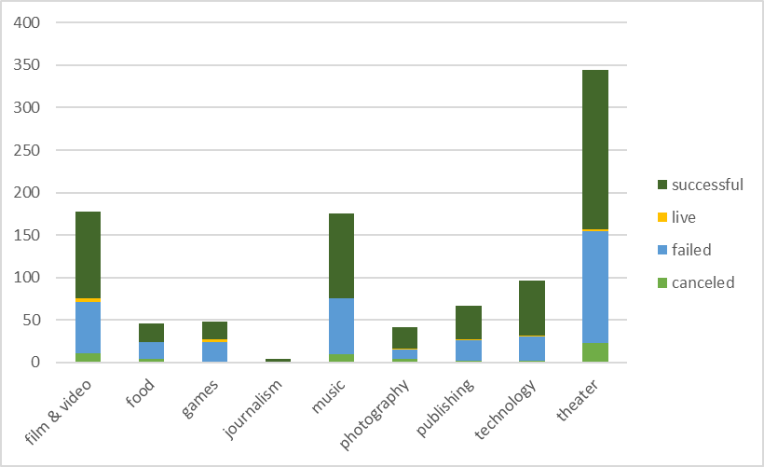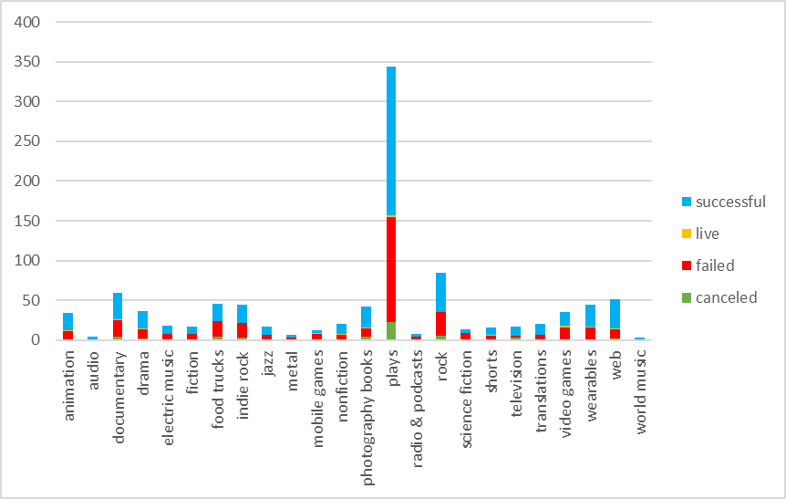 Given the data in these charts, the most successful crowdfunding campaigns are theater based, specifically plays. However, looking at the stacked graph of parent categories, theater-based projects also had a high rate of failure. This could perhaps be because there are so many more theater projects than there is any other type of crowdfunding. Although journalism was not as popular of a project, each project was successfully funded. When broken down by subcategory, science fiction had a higher chance of failure than any of the other categories.

The quality of these projects is not represented in this data. It could be that science fiction projects are popular with new companies with little experience in crowdfunding. It is also not known how much was spent on each project. Future data gathering could include cost and time to produce successful and failed crowdfunding campaigns to give an idea how much must be spent and given in order to reach a goal.

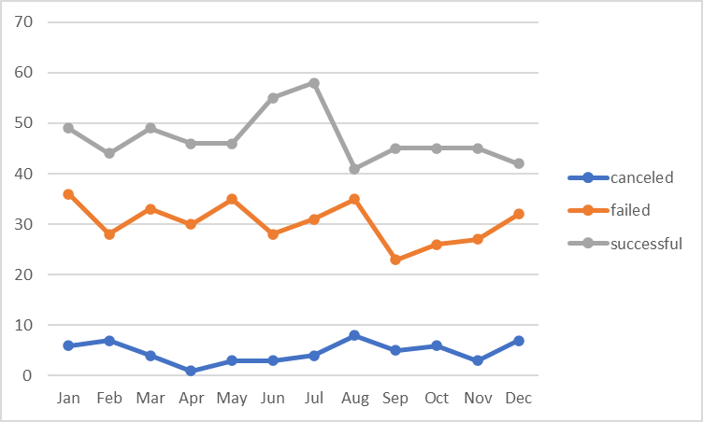 As can be seen in the time graph, the overall best month for crowdfunding projects is July. This is closely followed by August being the worst month, with the fewest successes, most failures, and highest chance of cancellation. A crowdfunding project in August is not recommended. While monitoring by monthly average over years gives an idea of best months, a yearly graph could show longer trends in types of crowdfunding and even in overall generosity. Some years might feel tighter than other years for average consumers. A yearly trend may show that overall, backers are donating less and less every year.